# Practical 12

**Q.Using AWT, write a program to create two buttons labelled ‘A’ and ‘B’. When button ‘A’ is pressed, it displays your personal information (Name, Course, Roll No, College) and when button ‘B’ is pressed, it displays your CGPA in previous semester.**

**Code:-**

### package Dhruv_Java; import java.util.*; import java.awt.*; import java.awt.event.*;

**public class practwelve {**

### public static void main (String[] args) {

***// create instance of frame with the label***

### Frame f = new Frame("Details");

***// create instance of frame with the label***

### final TextArea tf=new TextArea(); final TextArea tf1=new TextArea(); tf.setBounds(50,50, 160,200);

**tf1.setBounds(230,50, 160,200);**

***// create instance of button with label* Button name = new Button("Name"); Button cgpa = new Button("Cgpa");**

### String ne="Dhruv Bhardwaj"+"\n"+"B.sc.Hons.(Comp. Sci)"+"\n"+"18072"+"\n"+"ARSD COLLEGE"+"\n";

**String cg="CGPA: 9.99"+"\n";**

***// set the position for the button in frame* name.setBounds(80,250,80,30); cgpa.setBounds(260,250,80,30); name.addActionListener(new ActionListener() {**

### public void actionPerformed (ActionEvent e) { tf.append(ne);

***// tf.setText("Dhruv Bhardwaj");***

### }

**});**

### cgpa.addActionListener(new ActionListener() { public void actionPerformed (ActionEvent e) {

**tf1.append(cg);**

### }

**});**

***// add button to the frame***

### f.add(name);

**f.add(cgpa);**

### f.add(tf);

**f.add(tf1);**

***// set size, layout and visibility of frame***

### f.setSize(400,400); f.setLayout(null); f.setVisible(true);

**}**

**}**

**Output:-**

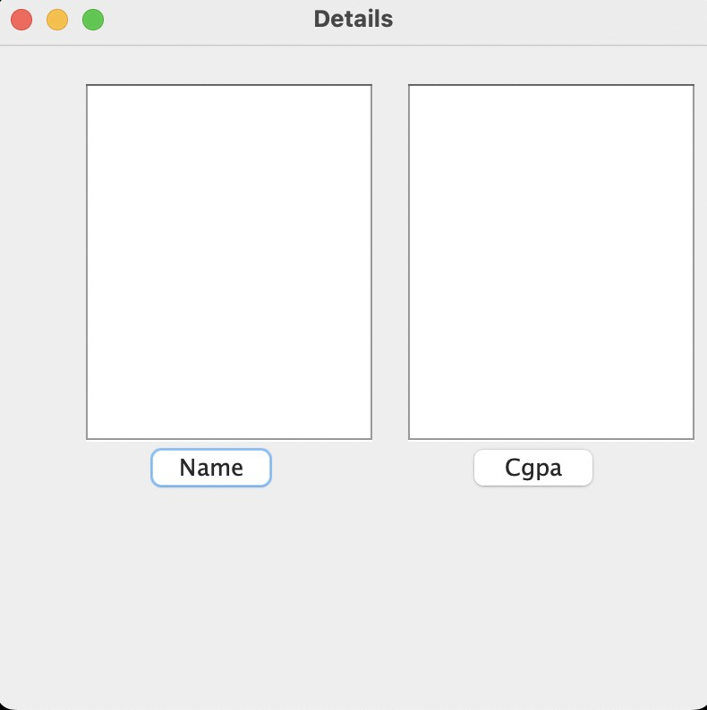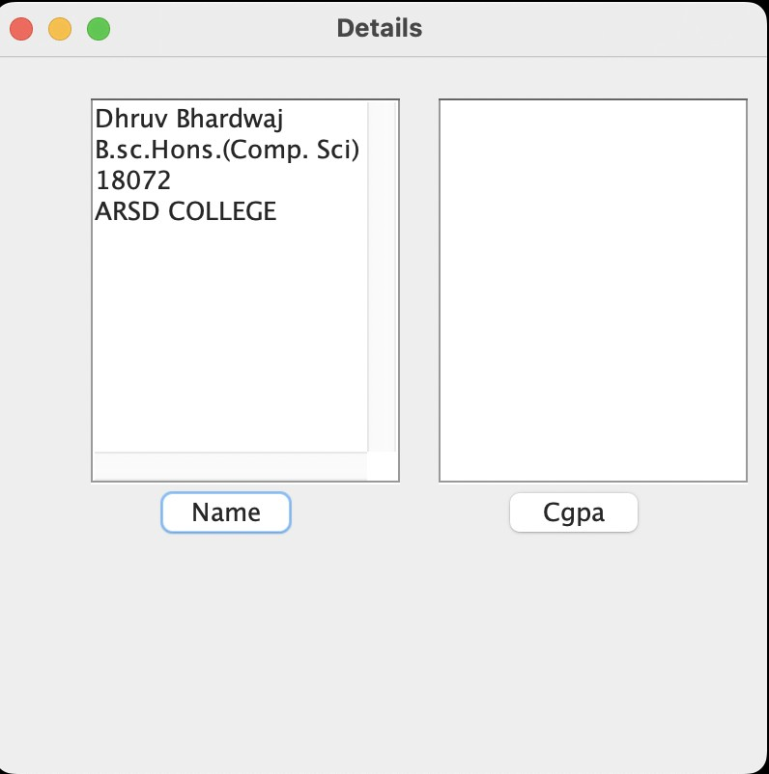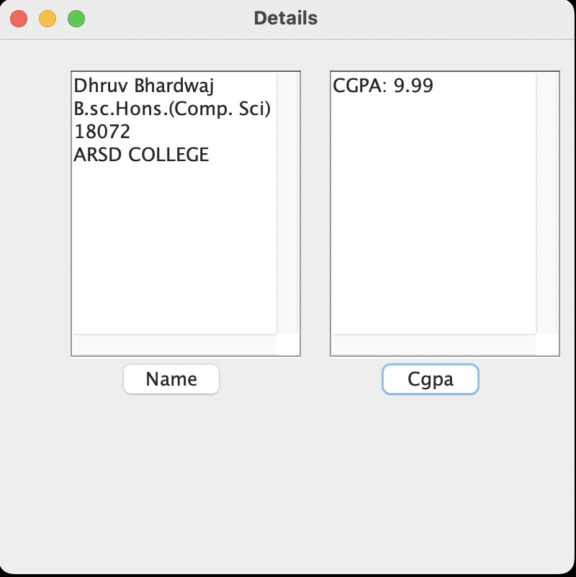

# Practical 13 Version:0.9

Q.Rewrite all the below GUI programs using Swing.

**a)Write a program to create a frame using SWING. Implement mouseClicked( ), mouseEntered( ) and mouseExited( ) events. Frame should become visible when mouse enters it.**

**Code:-**

package Dhruv_Java; import java**.**util**.\***; import java**.**awt**.\***; import java**.**awt**.**event**.\***; import javax**.**swing**.\***;

**public class** practhirtheen { JLabel l;

practhirtheen() {

JFrame f = new JFrame("Swing Frame");

l = new JLabel("", SwingConstants.CENTER); l.setBounds(15, 110, 260, 30);

f.add(l);

f.addMouseListener(new MouseAdapter() { @**Override**

**public void** mouseClicked(MouseEvent e) { l.setText("Mouse Clicked");

}

### @Override

**public void** mouseEntered(MouseEvent e) { l.setText("Mouse Entered");

}

### @Override

**public void** mouseExited(MouseEvent e) { l.setText("Mouse Exited");

}

});

f.setSize(300, 300); f.setLayout(null); f.setVisible(true);

f.setDefaultCloseOperation(JFrame.EXIT_ON_CLOSE);

}

**public static void** main(String[] args) { SwingUtilities.invokeLater(new Runnable() {

**public void** run() { new practhirtheen();

}

});

}

}

**Output:-**

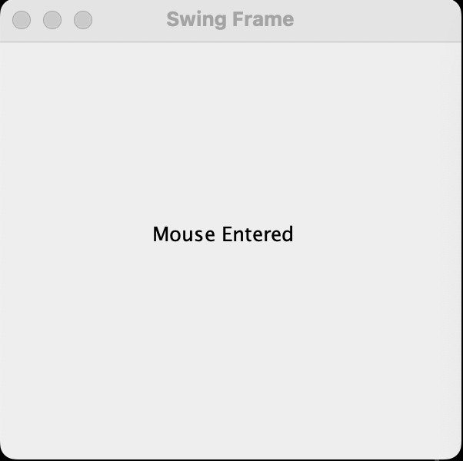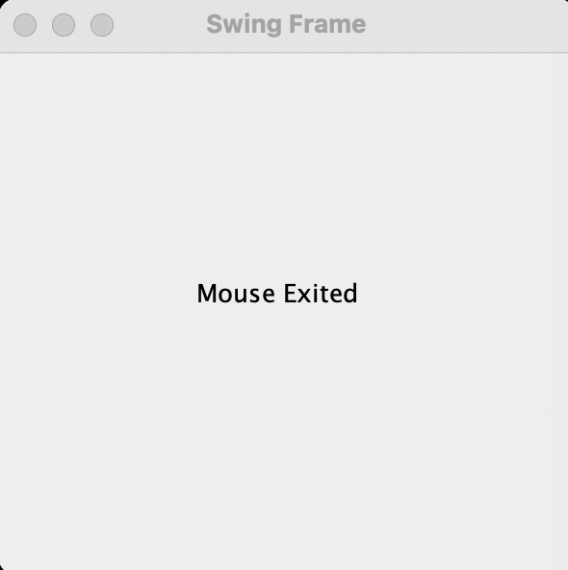

1. **Using SWING, write a program to display a string in frame window with pink color as background.**

**Code:-**

package Dhruv_Java; import java.awt.*; import java.awt.event.*; import javax.swing.*;

public class practhirtheen { JLabel l;

practhirtheen() {

JFrame f = new JFrame("Swing Pink");

l = new JLabel("This is some text", SwingConstants.CENTER); l.setBounds(15, 15, 260, 30);

f.add(l);

f.getContentPane().setBackground(Color.PINK); f.setSize(300, 100);

f.setLayout(null); f.setVisible(true);

f.setDefaultCloseOperation(JFrame.EXIT_ON_CLOSE);

}

public static void main(String[] args) { SwingUtilities.invokeLater(new Runnable() {

public void run() {

new practhirtheen();

}

});

}

}

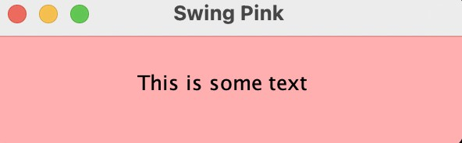**Output:-**

1. **Using SWING, write a program to create two buttons named “Red” and “Blue”. When a button is pressed the background color should be set to the color named by the button’s label.**

**Code:-**

package Dhruv_Java; iimport java.awt.*; import java.awt.event.*; import javax.swing.*;

public class practhirtheen { JButton btnRed, btnBlue; practhirtheen() {

JFrame f = new JFrame("Swing Buttons"); btnRed = new JButton("Red"); btnRed.setBounds(16, 20, 250, 30); btnRed.addActionListener(new ActionListener() {

@Override

public void actionPerformed(ActionEvent e) {

f.getContentPane().setBackground(Color.RED);

}

});

f.add(btnRed);

btnBlue = new JButton("Blue"); btnBlue.setBounds(16, 65, 250, 30); btnBlue.addActionListener(new ActionListener() {

@Override

public void actionPerformed(ActionEvent e) { f.getContentPane().setBackground(Color.BLUE);

}

});

f.add(btnBlue); f.setSize(300, 160); f.setLayout(null); f.setVisible(true);

f.setDefaultCloseOperation(JFrame.EXIT_ON_CLOSE);

}

public static void main(String[] args) { SwingUtilities.invokeLater(new Runnable() {

public void run() {

new practhirtheen();

}

});

}

}

**Output:-**

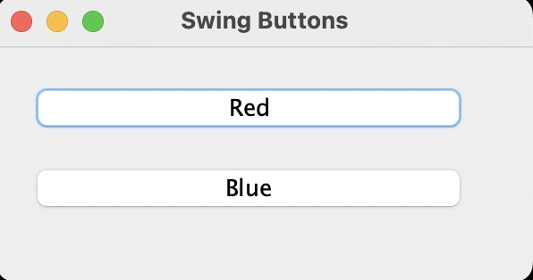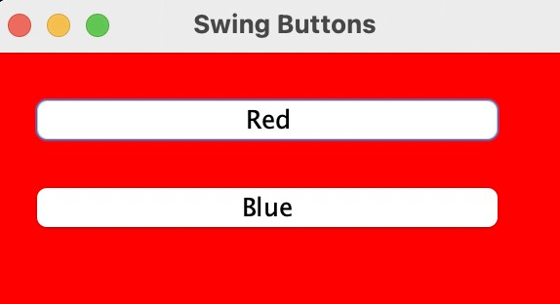

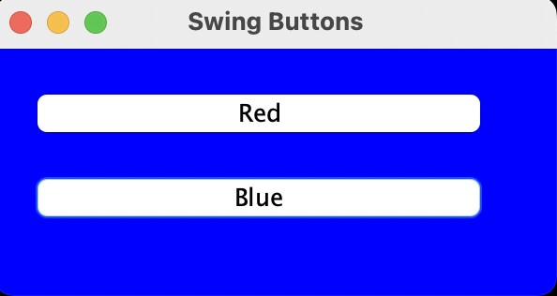

1. **Using SWING, write a program which responds to KEY_TYPED event and updates the status window with message (“Typed character is: X”). Use adapter class for other two events.**

**Code:-**

package Dhruv_Java; import java**.**awt**.\***; import java**.**awt**.**event**.\***; import javax**.**swing**.\***;

**class** KbdAdapter **extends** KeyAdapter { JLabel l;

KbdAdapter(JLabel l) { this.l = l;

}

### @Override

**public void** keyTyped(KeyEvent e) { l.setText("Typed character is: " + e.getKeyChar());

}

### @Override

**public void** keyPressed(KeyEvent e) { System.out.println("Pressed character is: " + e.getKeyChar());

}

### @Override

**public void** keyReleased(KeyEvent e) { System.out.println("Released character is: " + e.getKeyChar());

}

}

**public class** practhirtheen { JLabel l;

practhirtheen() {

JFrame f = new JFrame("AWT Keyboard");

l = new JLabel("", SwingConstants.CENTER); l.setBounds(15, 20, 250, 30); f.addKeyListener(new KbdAdapter(l)); f.add(l);

f.setSize(300, 110); f.setLayout(null); f.setVisible(true);

f.setDefaultCloseOperation(JFrame.EXIT_ON_CLOSE);

}

**public static void** main(String[] args) { SwingUtilities.invokeLater(new Runnable() {

**public void** run() { new practhirtheen();

}

});

}

}

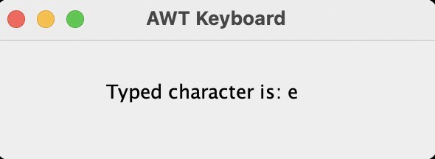Output:-

1. **Using SWING,write a program to create two buttons labelled ‘A’ and ‘B’. When button ‘A’ is pressed, it displays your personal information (Name, Course, Roll No, College) and when button ‘B’ is pressed, it displays your CGPA in previous semester.**

**Code:-**

**CGPA.java**

package Dhruv_Java; import java**.**awt**.\***; import java**.**awt**.**event**.\***; import javax**.**swing**.\***; **class** CGPA {

JLabel l;

JButton btnClose; CGPA(String cgpa) {

JFrame f = new JFrame("Previous Year CGPA");

l = new JLabel("Your CGPA was: " + cgpa, SwingConstants.CENTER); l.setBounds(20, 20, 250, 30);

btnClose = new JButton("Close"); btnClose.setBounds(90, 60, 100, 30); btnClose.addActionListener(new ActionListener() {

### @Override

**public void** actionPerformed(ActionEvent e) { f.dispose();

}

});

f.add(l); f.add(btnClose); f.setSize(310, 150); f.setLayout(null); f.setVisible(true);

f.setLocationRelativeTo(null); f.setDefaultCloseOperation(JFrame.DISPOSE_ON_CLOSE);

}

}

**INFORMATION.java**

package Dhruv_Java; import java**.**awt**.\***; import java**.**awt**.**event**.\***; import javax**.**swing**.\***; **class** Information {

JButton btnClose; JPanel panelForm;

JLabel labelName, labelCourse, labelRollNo, labelCollege; JTextField fieldName, fieldCourse, fieldRollNo, fieldCollege;

Information(String name, String course, String rollNo, String college) { JFrame f = new JFrame("Personal Information");

labelName = new JLabel("Name:"); labelName.setBounds(30, 30, 90, 23); labelCourse = new JLabel("Course:"); labelCourse.setBounds(30, 60, 100, 23); labelRollNo = new JLabel("Roll No.:"); labelRollNo.setBounds(30, 90, 80, 23); labelCollege = new JLabel("College:"); labelCollege.setBounds(30, 120, 90, 23); fieldName = new JTextField(name); fieldName.setBounds(120, 30, 210, 23); fieldName.setEditable(false);

fieldCourse = new JTextField(course); fieldCourse.setBounds(120, 60, 210, 23); fieldCourse.setEditable(false); fieldRollNo = new JTextField(rollNo); fieldRollNo.setBounds(120, 90, 210, 23); fieldRollNo.setEditable(false); fieldCollege = new JTextField(college);

fieldCollege.setBounds(120, 120, 210, 23); fieldCollege.setEditable(false);

btnClose = new JButton("Close"); btnClose.setBounds(110, 160, 140, 30); btnClose.addActionListener(new ActionListener() {

### @Override

**public void** actionPerformed(ActionEvent e) { f.dispose();

}

});

panelForm = new JPanel(); panelForm.setLayout(null); panelForm.add(labelName);

panelForm.add(fieldName); panelForm.add(labelCourse); panelForm.add(fieldCourse); panelForm.add(labelRollNo); panelForm.add(fieldRollNo); panelForm.add(labelCollege); panelForm.add(fieldCollege); panelForm.add(btnClose); f.add(panelForm); f.setSize(380, 250); f.setVisible(true); f.setLayout(null); f.setLocationRelativeTo(null);

f.setDefaultCloseOperation(JFrame.DISPOSE_ON_CLOSE);

}

}

## MAIN.java

package Dhruv_Java; import java**.**awt**.\***; import java**.**awt**.**event**.\***; import javax**.**swing**.\***;

**public class** practhirtheen **implements** ActionListener { JButton btnInfo, btnCGPA;

practhirtheen() {

JFrame f = new JFrame("Student Details"); btnInfo = new JButton("A"); btnInfo.setBounds(18, 100, 450, 100); btnInfo.addActionListener(this); f.add(btnInfo);

btnCGPA = new JButton("B"); btnCGPA.setBounds(18, 270, 450, 100); btnCGPA.addActionListener(this); f.add(btnCGPA);

f.setSize(500, 500); f.setLayout(null); f.setVisible(true); f.setLocationRelativeTo(null);

f.setDefaultCloseOperation(JFrame.EXIT_ON_CLOSE);

}

**public static void** main(String[] args) { SwingUtilities.invokeLater(new Runnable() {

**public void** run() { new practhirtheen();

}

});

}

### @Override

**public void** actionPerformed(ActionEvent e) { if (e.getSource() == btnInfo) {

new Information( "Dhruv Bhardwaj",

"BSc (Hons) Computer Science", "221/18072",

"ARSD College"

);

} else if (e.getSource() == btnCGPA) { new CGPA("9.99");

}

}

}

**Output:-**

